CS 340 Project Two README

About the Project/Project Title

This project is an interactive dashboard for Grazioso Salvare using the Austin Animal Center database. The dashboard allows users to filter animal records and view the results in a table, pie chart, and map.

Motivation

The purpose of this project is to make it easier for Grazioso Salvare to find dogs that meet their requirements for rescue training. The dashboard includes filters for Water Rescue, Mountain or Wilderness Rescue, and Disaster or Individual Tracking.

Getting Started

The Austin Animal Center dataset is stored in MongoDB. The dashboard connects to the database using the CRUD Python module created in Project One.

Run the ProjectTwoDashboard.ipynb file in Jupyter Notebook to start the dashboard.

Installation

Dependencies:
- Python
- MongoDB
- PyMongo
- Pandas
- Dash
- Plotly
- Dash Leaflet
- Jupyter Notebook

Tools Used

MongoDB was used to store animal data. It works well with Python through PyMongo and allows the dashboard to query the animal records. Dash and JupyterDash were used to build the dashboard and handle the interactive filters. Plotly was used for the pie chart, and Dash Leaflet was used for the map.

Usage

The dashboard has four filter options:
- Water Rescue
- Mountain or Wilderness Rescue
- Disaster or Individual Tracking
- Reset
Selecting a filter updates the data table, pie chart, and map to show the matching animals.

Screenshots
Starting Dashboard/Reset
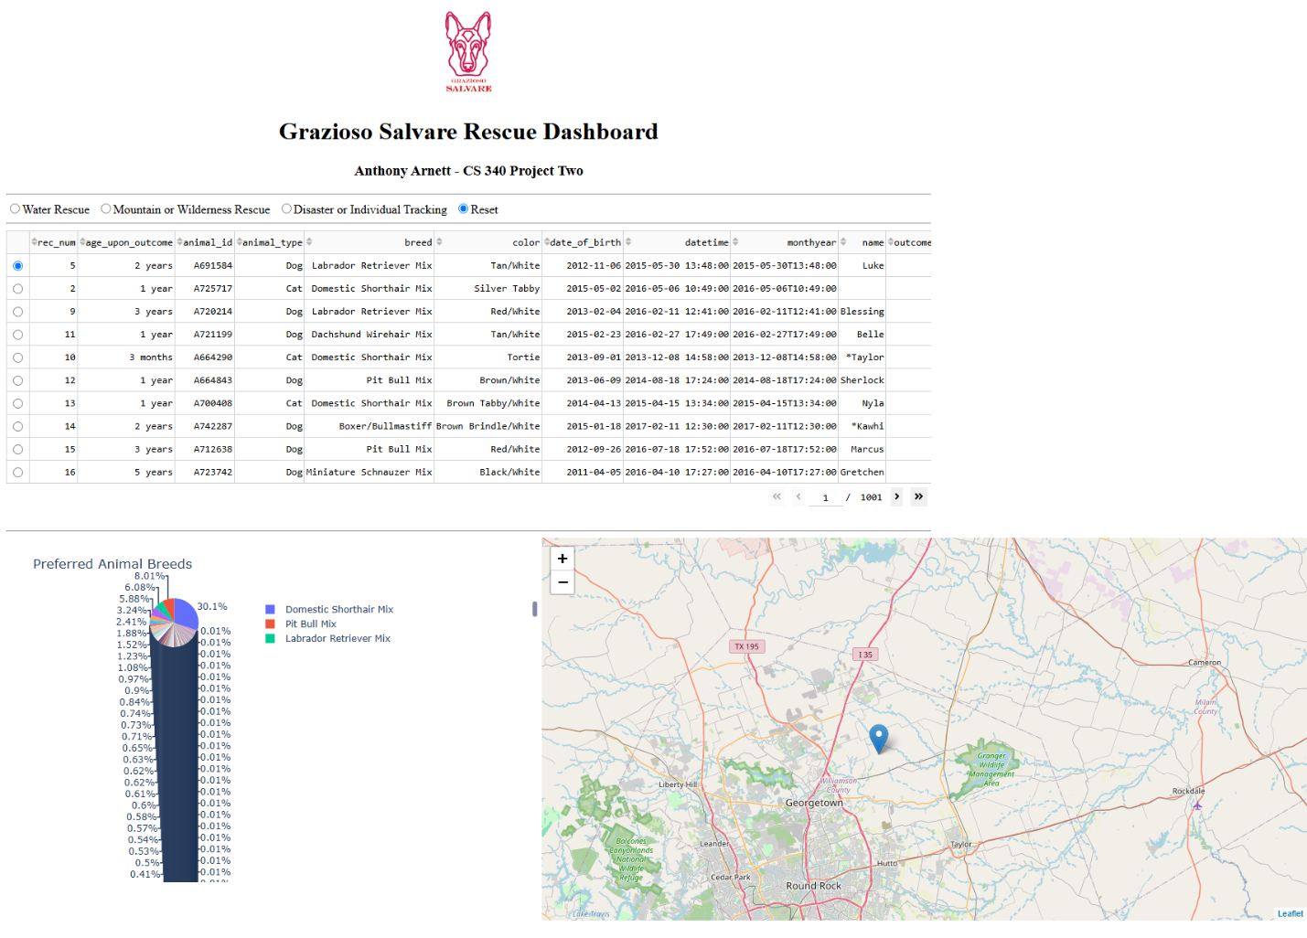

Water Rescue
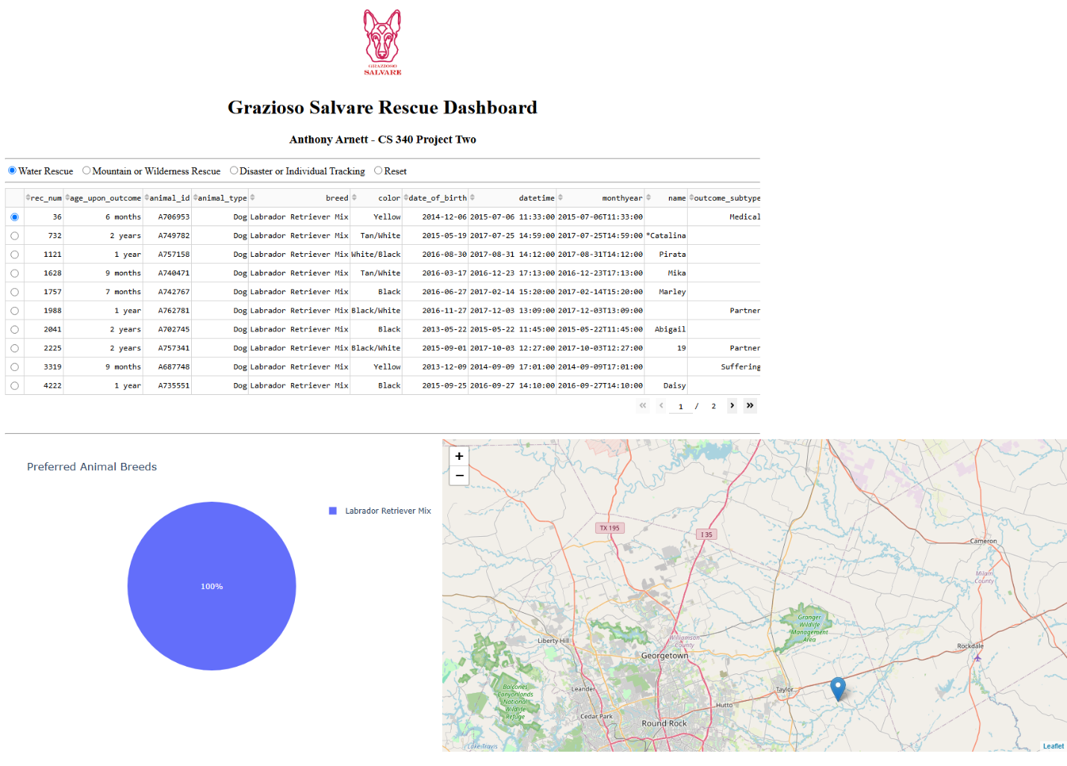

Mountain or Wilderness Rescue
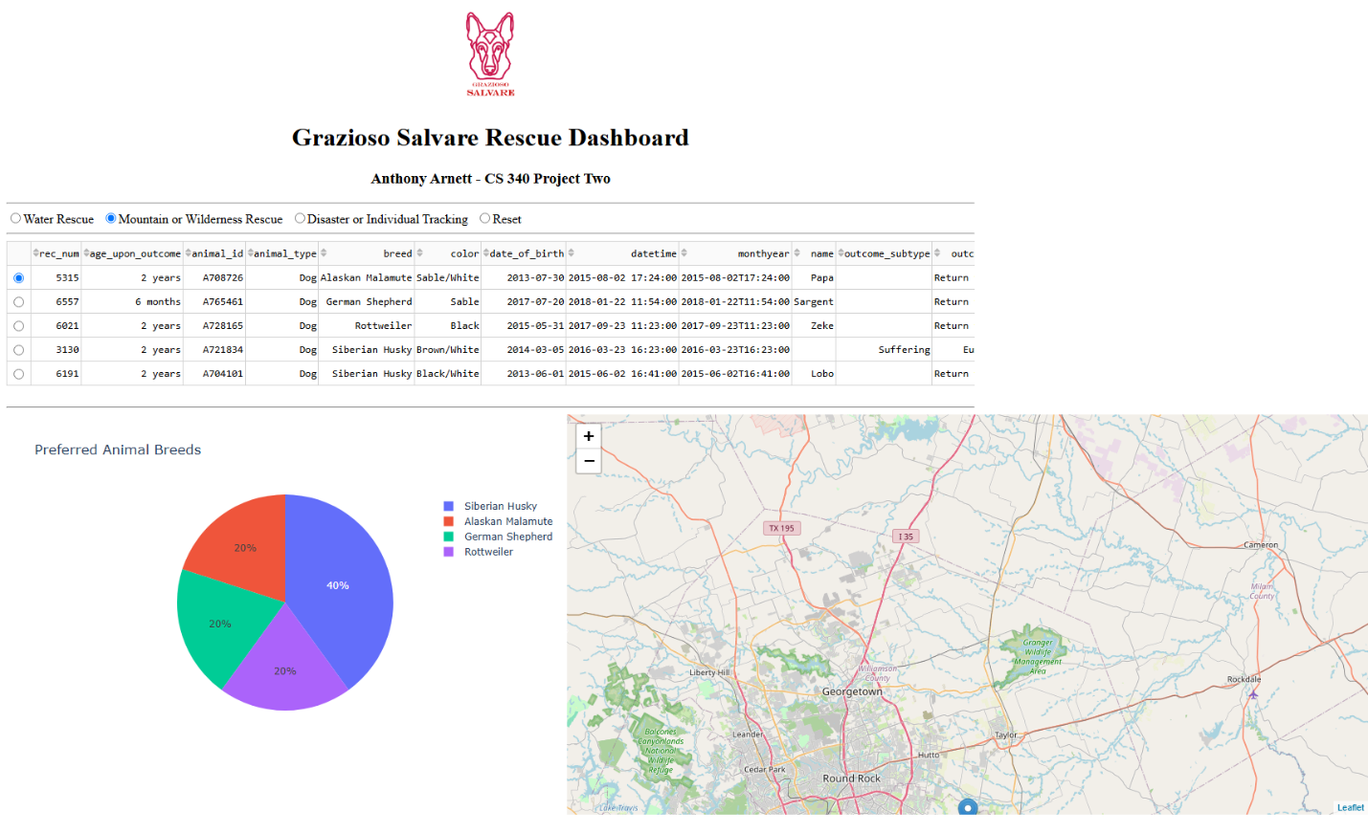
Disaster or Individual Tracking
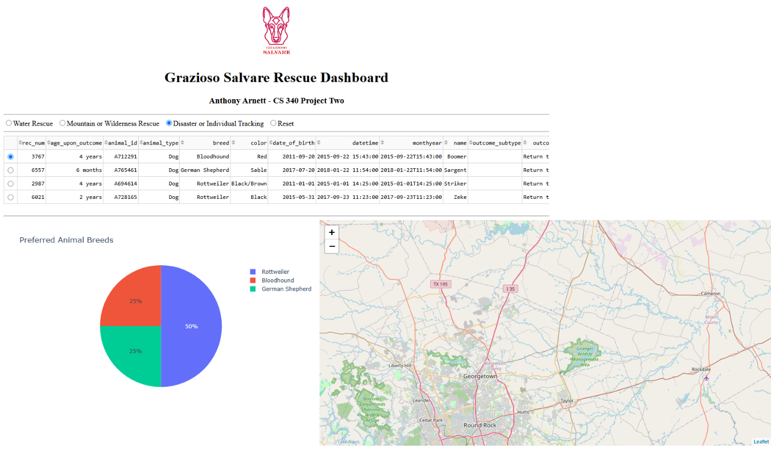

Development

I reused the CRUD Python module from Project One to connect the dashboard to MongoDB. I added the filters and used MongoDB queries to return dogs that matched each rescue type. I connected the table, pie chart, and map so they update with the filtered data.

Challenges

One issue was the MongoDB _id field because the ObjectId type could cause the Dash table to crash. I removed the _id column from the dataframe before displaying the data.

Reproducing

- Set up MongoDB with the Austin Animal Center dataset
- Make sure the aacuser account has access to the database
- Install the required Python packages
- Place the CRUD Python module, dashboard notebook, and logo in the same project directory.
- Open and run ProjectTwoDashboard.ipynb

Resources
MongoDB: https://www.mongodb.com/
PyMongo: https://pymongo.readthedocs.io/en/stable/
Dash: https://dash.plotly.com/

Contact
Anthony Arnett

